**Project Documentation:**

**Week 1 – Task 1:**

***Personal Portfolio Website***

**Submitted By: Zara Khan**

**Submitted To: A&D Tech**

**Dated: 1st July, 2024**

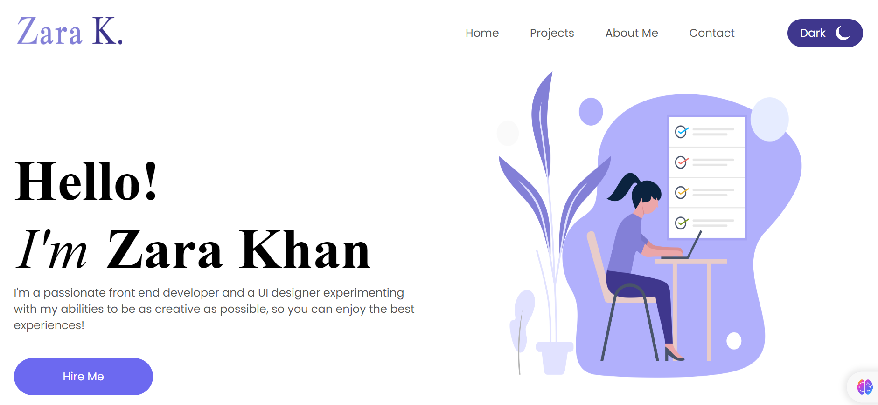



***Problem Statement***

Create a simple personal portfolio website using HTML, CSS, and JavaScript. This website will showcase your bio, skills, projects, and contact information.

***Solution Overview***

I approached the project by watching YouTube tutorials and referencing W3Schools to gather insights and best practices. The goal was to create a website that is visually appealing and professional, while also ensuring it remains user-friendly and responsive across various devices.

***Challenges and Resolutions***

* **Challenge: Responsiveness**
* Ensuring the website displays correctly on different screen sizes and devices.
* **Resolution:** Used flex and other layout properties in CSS to create a responsive design.
* **Challenge: Form Implementation**
* Implementing a functional contact form with validation.
* **Resolution:** Watched tutorials on creating a functional form and Utilized HTML5 form attributes for basic validation.

***Instructions***

**Setting Up the Project**

1. **Download the Project Files:**
   * Clone the repository from [GitHub link].
   * Alternatively, download the project zip file and extract it to your local machine.
2. **Open in Visual Studio Code (VS Code):**
   * Launch VS Code.
   * Open the entire project folder using File > Open Folder.

**Running the Project**

1. **Navigate to the Main Page:**
   * In the VS Code sidebar, locate and open Personal_Portfolio.html.
   * This file serves as the main entry point to the portfolio website.
2. **Exploring Other Pages:**
   * Each page provides details on skills, projects, and contact information.
3. **Testing Responsiveness:**
   * Use VS Code's built-in preview or open the website in different browsers and devices to ensure responsiveness.